# **Methods**

## *Study design*

We did a whole-lake AgNPs addition into Lake 222 (L222, experimental) and Lake 239 (L239, reference) at the IISD-Experimental Lakes Area in northwestern Ontario, Canada (49◦41'42.0"N; 93◦43'27.7"W) during the 2014 and 2015 ice free seasons (post-AgNPs addition). Prior to the AgNPs addition, we monitored both lakes in 2012 to evaluate their pre-AgNPs addition biochemical conditions. L222 and L239 were chosen because they have similar physical and chemical characteristics and share two common fish species: the yellow perch and the northern pike (*Esox lucius*). L222 is an oligotrophic lake on the Canadian Shield with a surface area of approximately 163, 900 m2, a volume of 7.2 x 105 m3, and a maximum depth of 6.3 m (Hayhurst, 2018). L239 is also an oligotrophic lake with a surface area of 542, 800 m2, a volume of 5.9 x 106 m3, and a maximum depth of 30.4 m. Both lakes share similar conductivity and pH but L222 has on average higher phosphorus and DOC concentrations. On August 6th-7th 2012 and August 11th-12th 2014 and 2015, we sampled twenty yellow perch in each lake and tested them for nutrient excretion. Yellow perch was selected because it is the primary fish species in both L222 and L239. They are an important prey for the northern pike and are widespread in North America.

## *Whole-lake AgNPs addition*

A total of 15 kg of polyvinylpyrrolidone (PVP)-capped AgNPs with additional gum arabic stabilization were added in L222 from a point source near the lake in-flow over two field seasons in 2014 and 2015. In 2014, 9 kg were added over 18 weeks from mid-June to late October, while in 2015, 6 kg were added over 14 weeks from early May to late August. This allowed to simulate point source inputs from municipal wastewater treatment plants. AgNPs were prepared and characterized following the procedure described in Martin et al. (2017). This generated concentrated AgNP suspensions (5.2 g L-1) consisting of 30–50 nm diameter particles. These were pumped into the lake every 6 h using a peristaltic pump on a timer. Mesocosm and whole-lake experiments at the IISD-ELA have found that AgNPs were present at all sampled locations throughout the lake within 24 h of the first dose and in all lake layers over the growing season (Rearick et al 2018). Total silver concentrations (TAg) in the lake epilimnion varied between 0 µg L-1 and 17.4 µg L-1 (Conine et al 2018) while dissolved Ag remained in low concentrations (<0.4g/L) and was an overall low contributor to TAg (Rearick et al 2018). AgNPs were overall relatively stable and persistent in the lake likely due to the lake low ionic strength and high DOC concentrations (Furtado et al. 2015).

## *Excretion experiment and nutrient analyses*

Yellow perch was collected by seine net and only fish juveniles (indicated by fish total length) were kept for the experiment. This choice was made based on the metabolic theory of ecology which recognizes the scaling effect of body size on physiological rates (here, excretion rates; Brown et al (2016)). Following collection, each fish was placed in a whirl-pak with 0.75L of prefiltered water collected from each source lake. Bags containing sampled individuals and five additional bags without individuals (controls) were incubated for 30 minutes in a tub filled with untreated lake water and kept in the shade to maintain water temperature at ambient lake temperature. After incubation, individuals were removed from the bags, placed on ice, and weighted (wet mass) in the laboratory. Wet mass was then converted to dry mass using a conversion factor of 0.25 (Vanni and McIntyre, 2017). Fish total length and dry mass ranged from 39 to 107mm ± 13.9mm and 0.11 to 3.75g ± 0.5g, respectively.

Water samples from each incubation were filtered, kept on ice until analysis, and quantified as total dissolved nitrogen (TDN), total dissolved phosphorus (TDP), DOC, and TAg. TDN was measured using persulfate digestion on a spectrophotometer and TDP was quantified using the molybdate blue method after digestion with persulfate (Murphy and Riley 1962). DOC was assayed after combustion, acidification, and purging of inorganic C on a total organic C analyzer (Sharp et al. 1993). Lastly, TAg was analyzed by first preserving screened water and acidifying the sample to 4% nitric acid, then digesting all silver samples using a nitric acid/hydrogen peroxide digestion followed by inductively coupled plasma mass spectrometry (ICP-MS) (Furtado et al. 2015).

## *Statistical analyses*

We ran two-way Anova using the command aov (R studio version reference). We first tested the effect of AgNPs addition on yellow perch TDN and TDP excretions and on the molar ratio of N:P, C:N, and C:P excretions by comparing nutrient excretions in L222 vs. L239 both pre- (2012) and post-AgNP addition (2015; model structure: *nutrient excretion ~ Lake*Year* for log-transformed TDN and TDP and untransformed DOC, N:P, C:N, and C:P excretions. Due to time constraints, DOC excretions could only be compared between the lakes post-AgNP addition in 2014 and TDP excretions were the only ones assessed both in 2014 and 2015. For TDP excretions, we followed up the anova tests with a pairwise post-hoc test (WHICH) to compare both lakes in each year. Lastly, we tested the effect of the year of AgNPs additions (2014 or 2015) in L222 on Tag excretion (*Tag excretion ~ Year*)*.*

**Question 1: Do AgNPs have an effect on yellow perch N excretion?**

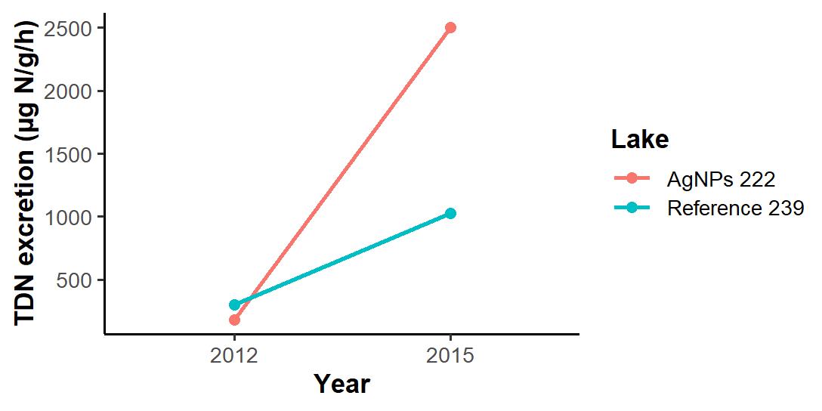

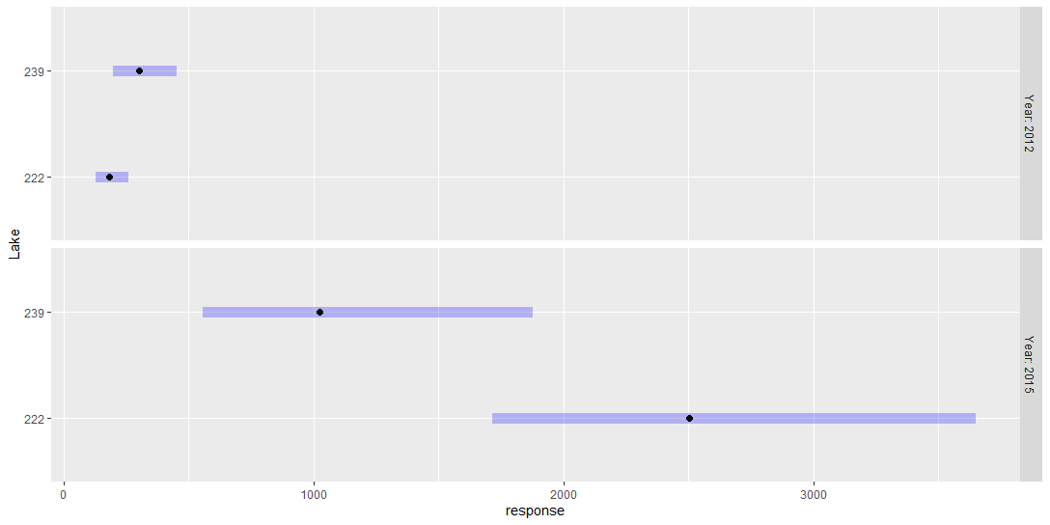

**Question 1: Do AgNPs have an effect on yellow perch P excretion?**

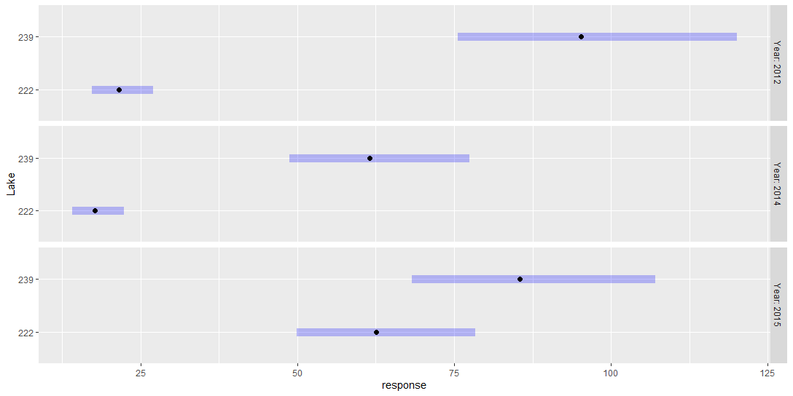

**Question 2: Does TAg release by yellow perch vary from year 1 (2014) to year 2 (2015) of AgNPs addition?**